PostmasterGS Stamp Album Page Generator v1.5.5

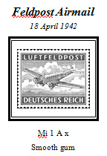
Figure 1.1
- Overview. The PostmasterGS Stamp Album Page Generator (PMGSSAPG) is a COM add-in for Microsoft Publisher that is designed to automate the insertion of frames, photos, and text onto stamp album pages. The add-in allows the user to build a frame to display the stamp, insert a photo within the frame, and surround it with up to four text boxes of custom text. In addition, the add-in allows the user to store stamp data in Microsoft Excel for batch import of multiple stamps in a single step.
- System Requirements. PMGSSAPG requires Microsoft Publisher and, if utilizing the batch import function, Microsoft Excel. The add-in has been tested with Publisher/Excel 2007, 2010, and 2013.
  - Known Issues. Publisher 2013 has a bug in its coloring of grayscale photos. Microsoft is aware of the issue, but there is currently not an automated workaround. Details and manual workaround are included in the grayscale instructions below.
- Installation. The installation package consists of two files: PMGSSAPG15Setup.msi and setup.exe. To install, run setup.exe. It is highly recommended to install the add-in to the default location chosen by the installer -- installation to a subdirectory that requires Administrator rights to access can limit the functionality of the add-in. Also, the add-in will not run properly if Publisher or Excel are set to Run as Administrator.
  - Upgrading. If upgrading from a previous version,
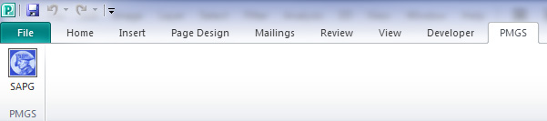
- Accessing the Add-In. After installing the add-in, there will be a new tab in Publisher labeled PMGS, with a group labeled PMGS and a button labeled SAPG. Click the button to launch the add-in.
- Main Components of the Add-In. There are three main components of the add in
Figure 4.1 – PMGS Tab
  - Single Entry. For inserting a single stamp box onto the album page.
  - Batch Entry. For inserting multiple stamp boxes onto the album page.
  - Border Insertion. For inserting a simple border around the album page.

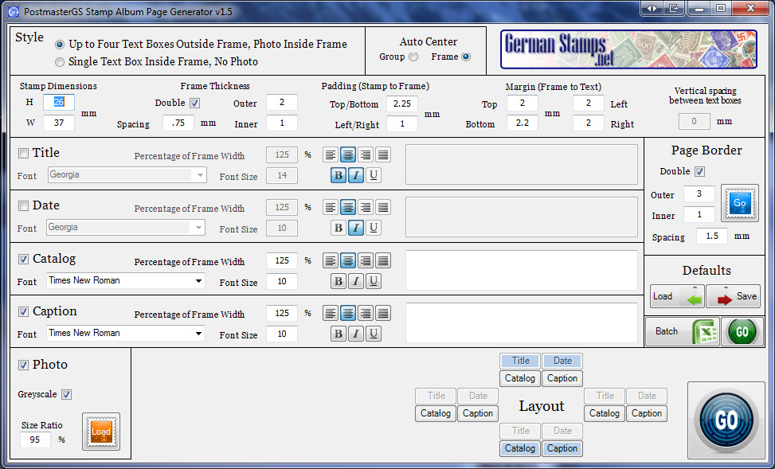
- Options on the Add-In Window.
Figure 6.1 – Add-In Window
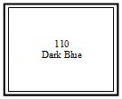
  - Style. Switch between two styles of stamp box. Option 1 inserts a frame and up to four text boxes, with a photo. Option 2 inserts a frame with a single text box in the center.
Figure 6.2a – Option 1
Figure 6.2b – Option 2

  - Stamp Dimensions. These boxes are for entry of the height and width of the stamp itself, as measured in millimeters. These boxes are only used for single entry, as during a batch entry the stamp dimensions are pulled from the batch entry source.

  - Frame Thickness. This section controls the appearance of the frame into which the stamp is to be inserted.

    - Double. Allows for insertion of a double-lined frame, as opposed to a single-lined frame.
Figure 6.3 – Double Frame & Single Frame
    - Spacing. Controls the spacing, in millimeters, between the inner and outer frames in a double frame.
    - Outer & Inner. Control the width, in points, of the outer (single and double frame) and inner (double frame only) frames.
  - Padding (Stamp to Frame). Set the distance between the top and bottom of the stamp, and the left and right sides of the stamp, respectively, and the frame. Note that this does not control the spacing between the photo and the frame, but rather the stamp itself and the frame.
  - Margin (Frame to Text). Set the distance, in millimeters, between the outer frame and any surrounding text boxes.
  - Text Boxes. The add-in allows the user to insert up to four text boxes. In the Add-In Windows, these text boxes are labeled as Title, Date, Catalog, and Caption. As the options for these four text boxes are identical, they will be discussed here as one.
    - Checkbox. The checkbox determines whether the text box is on or off. If the text box is off, the text box options are grayed out, and will be disregarded by the add-in.
    - Font. Sets the font of the text box. The fonts are pulled from the list of installed Windows fonts.
    - Font Size. Sets the font size.
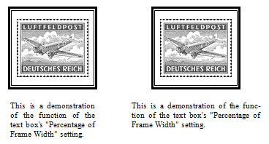
    - Percentage of Frame Width. Sets the text box width as a percentage of the overall frame width. For example, if the user wanted the text box to be the same width as the frame, this box should be set to 100%. If, however, the user wanted the text box to be slightly wider than the frame, 150% would be a more appropriate option.
Figure 6.4 – Percentage of Frame Width set to 100% (left) and 150% (right).
    - Text Alignment Buttons. Set the text alignment within the text box to left, center, right, or fully justified.
    - Font Style Buttons. Set the font style to bold, italics, underlined, of a combination. Note that not all font style are available with some fonts.
    - Text Box. For entry of the text to be inserted in the generated text box. The text box will show a preview of the font style, size, and alignment (with the exception of fully justified, which cannot be previewed due to limitations in Microsoft VB.net). These text boxes are only used for single entry, as during a batch entry the text box contents are pulled from the batch entry source.

  - Photo. The Photo option allows the user to insert a photo within the stamp frame.
    - Checkbox. Turns the photo on or off.
    - Grayscale. Inserts a grayscale photo, as opposed to a full-color photo.
Figure 6.5 – Grayscale (left) and full-color (right) photos.

NOTE: Due to a bug in Publisher 2013, the add-in cannot automatically insert a grayscale photo. To manually change a photo to grayscale in Publisher 2013:
      - Right click on the photo and select Ungroup
      - Click off of the object to clear the selection.
      - Left click to select just the photo.
      - Click on the Format tab at the top of the screen.
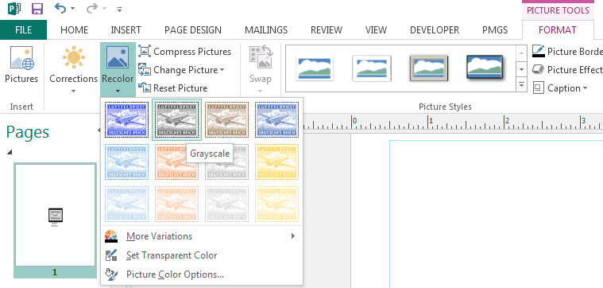
      - Click the Recolor button, and select the grayscale photo
Figure 6.6 – Manually changing the photo to grayscale

    - Size Ratio. Sets the size of the photo as a percentage of the actual size of the stamp. This allows the photo to be shrunk slightly so as to avoid it being visible behind a stamp mounted with a hinge or a clear hingeless mount.

    - Load Button. Loads a dialog box which allows the user to select the photo. The selected photo will be displayed to the right of the Load button. The loaded photo is only used for single entry, as during a batch entry the path to the photo is pulled from the batch entry source.

  - Vertical Spacing Between Text Boxes. The vertical distance, in millimeters, between text boxes when two or more text boxes are positioned on the same side of the frame.
Figure 6.7 – Vertical spacing between “Mi 1 A x” and “Smooth gum”
  - Layout Buttons. Control the layout of the four text boxes relative to the frame. Text boxes which are off are grayed out.
  - Placement. When the frame, photo, and text boxes are placed on the page, they are grouped into a single unit. These option buttons control the initial placement of the group – with either the entire group centered on the page, or with the frame centered on the page.
  - Border. Allows the insertion of a simple border around the margins of the page (the light blue lines on the Publisher page).
    - Double. Allows for insertion of a double-lined border, as opposed to a single-lined border.
    - Spacing. Controls the spacing, in millimeters, between the inner and outer lines of a double border.
    - Outer & Inner. Control the width, in points, of the outer (single and double border) and inner (double border only) border lines.
    - Go Button. Generates the border.
  - Defaults. Allows the user to store default setting for all options on the Add-In Window.
    - Load Button. Load defaults from file.
    - Save Button. Save defaults to file.
  - Batch Button. Loads Microsoft Excel to allow batch processing. (See Section 7).
  - Green Go Button. Loads batch data and generates the Batch Entry.
  - Blue Go Button. Generates a Single Entry.

- Batch Entry. After clicking the Batch Entry button, Excel loads and the user is presented with a sample spreadsheet.
- Important Limitations in Using the Spreadsheet. The spreadsheet is designed such that the user can keep data permanently in the spreadsheet, with separate worksheets for different collecting areas, etc. There are a few limitations, however.
  - New Columns. The user can add new columns to the spreadsheet. New columns must not, however, be inserted between columns A and H. When the data is exported from Excel to Publisher, Publisher uses the columns to determine what data goes in what blanks. The addition or deletion of columns between A and H will throw off the export and lead to unpredictable, incorrect results.
  - New Worksheets. The user can add new worksheets to track other collecting areas. However, to create a new worksheet, the user should copy an existing worksheet and delete the existing data, not create a blank new spreadsheet. Again, this is to preserve the very strict formatting requirements of the export/import process.
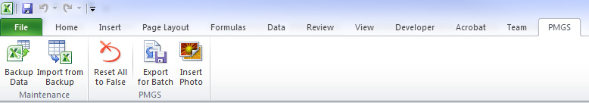
- Using the Spreadsheet. The spreadsheet has a new tab at the top labeled PMGS. On this tab are two groups, Maintenance and PMGS.
Figure 9-1. – PMGS Tab
- Maintenance. The buttons on this tab are primarily for use when upgrading to a later version of the PMGSSAPG.
  - Backup Data. Allows the user to create a backup Excel file of the data. Functionally the same as File, Save As.
  - Import Data From Backup. Overwrites the existing data with data from a backup Excel file. The primary purpose of this function is to preserve a user’s data on upgrade of the software, as any upgrades to the code behind the spreadsheet usually require the spreadsheet to be overwritten. Following an upgrade, the user can then use this function to re-import all existing data into the new version of the spreadsheet.
- PMGS. This tab controls the function of the batch export spreadsheet.
  - Reset All to False. Resets all rows on the current, active worksheet to FALSE. Note, it does not reset rows on any non-active worksheets to FALSE.
  - Export to Batch. Exports all TRUE rows on the current, active worksheet for import into Publisher. Note, it does not export rows from any non-active worksheets.
  - Insert Photo. Opens a dialog box which allows the user to select a photo. Upon selection, the path to the photo is inserted in the active cell. This prevents the user from having to manually enter the filepath to any photos.

